PROJECT BASED LEARNING
ON

MOVIE RECOMMENDATION SYSTEM

MACHINE LEARNING (BCS-DS-652)
Submitted by:
REVANTH SAI BOMMA 1/23/SET/BCS/417
HIMANI SHARMA 1/23/SET/BCS/425

Under the Guidance of
Ms. Shaveta Jain
(Assistant Professor)

in partial fulfillment for the award of the degree of
BACHELOR OF TECHNOLOGY
IN
Computer Science & Engineering


Faculty of Engineering & Technology
MANAV RACHNA INTERNATIONAL INSTITUTE OF RESEARCH AND STUDIES, Faridabad
NAAC ACCREDITED ‘A’ GRADE
Aug – Dec, 2025

TABLE OF CONTENTS
- Introduction
1.1 Background and Motivation
1.2 Problem Statement
1.3 Objectives
1.4 Scope of the Study
1.5 Tools and Technologies Used
- Literature review
  - Introduction
  - Movie Rating Prediction using Machine Learning
  - Sentiment Analysis for Text-Based Insights
  - Decision Tree Models in Predictive Analytics
  - Integration of Sentiment and Machine Learning for Rating Prediction
  - Research Gap Identified
- Problem statement
  - Overview of the Problem
  - The Research Gap
  - Key Problem to Address
  - Objectives of Solving the Problem
  - Problem Formulation
  - Expected Outcome
- Methodology
  - Overview
  - Workflow of the Methodology
  - Algorithm Used: Decision Tree Regressor
  - Evaluation Metrics and Formulas
  - Methodology Flow Diagram
- Results&Discussion
  - DecisionTree Regressor Performance
  - Comparison Tables
  - Comparison Graphs
- References

1. INTRODUCTION
1.1 Background and Motivation
In today’s digital era, movies have become a dominant form of entertainment and cultural expression. The success or failure of a movie largely depends on public perception, critical reviews, and audience engagement.
Online platforms such as IMDb (Internet Movie Database) serve as one of the most trusted sources for evaluating the popularity and quality of movies through user ratings, reviews, and the number of votes.
With the rapid growth of data-driven technologies and machine learning (ML), it has become possible to extract meaningful insights from movie data to predict audience preferences, forecast ratings, and classify films into performance categories such as Hit, Average, or Flop.
The motivation behind this project lies in combining quantitative data (votes) and qualitative sentiment data (movie overview text) to predict IMDb ratings using a predictive model. This integration allows a deeper understanding of how textual sentiment and audience interaction collectively influence movie ratings.
1.2 Problem Statement
Traditional movie rating systems rely heavily on explicit user feedback and votes, which may not fully represent the emotional response of viewers. However, a movie’s overview text or storyline description carries implicit sentiment that can reflect the tone, emotion, and appeal of the film.
Hence, there is a need for a hybrid analytical model that combines both textual (sentiment-based) and numerical (statistical) features to:
- Predict IMDb ratings accurately, and
- Classify movies into categories (Hit, Average, Flop).
This project aims to build such a model using sentiment analysis and decision tree regression, providing an interpretable and efficient solution for rating prediction.
1.3 Objectives of the Project
The main objectives of this project are as follows:
- To analyze movie data and extract sentiment polarity from the “Overview” column using TextBlob.
- To integrate both numerical (No. of Votes) and textual (Sentiment) features into the predictive model.
- To apply a Decision Tree Regressor to predict the IMDb rating of movies.
- To evaluate the model using performance metrics like MAE, MSE, and R² Score.
- To categorize movies into performance-based groups: Hit, Average, and Flop, and assess classification accuracy.
- To visualize results through graphs and confusion matrices for a better understanding of model performance.
1.4 Scope of the Study
This project focuses on the IMDB Top 1000 Movies dataset, which includes attributes such as movie title, overview, number of votes, and IMDb rating. The study emphasizes:
- Predicting continuous IMDb rating values (regression task).
- Deriving sentiment polarity using TextBlob, a natural language processing (NLP) library.
- Applying and evaluating a Decision Tree Regression model for interpretability and accuracy.
- Providing insights that can assist filmmakers, producers, and OTT platforms in understanding audience preferences.
1.5 Tools and Technologies Used
The project employs the following tools and technologies:
- Programming Language: Python
- Libraries Used:
  - pandas, numpy – for data manipulation and analysis
  - matplotlib, seaborn – for visualization
  - sklearn – for machine learning modeling and evaluation
  - TextBlob – for sentiment analysis
- Algorithm: Decision Tree Regressor
- Dataset: IMDb Top 1000 Movies Dataset

2. LITERATURE REVIEW
2.1 Introduction
The prediction of movie ratings and success outcomes has been an active area of research within the fields of machine learning (ML), data mining, and natural language processing (NLP). Researchers have explored how textual data, such as reviews and summaries, along with quantitative data, like votes, revenue, or popularity, can be integrated to create predictive models. This section reviews prior works that contribute to the understanding of movie rating prediction, sentiment analysis, and decision tree-based regression models relevant to this project.
2.2 Movie Rating Prediction using Machine Learning
Numerous studies have focused on predicting movie ratings using structured features and metadata from IMDb or similar databases.
- Gupta and Yadav (2020) utilized regression algorithms like Linear Regression, Random Forest, and Support Vector Machines (SVM) to predict IMDb ratings based on movie attributes such as duration, genre, and number of votes. Their findings indicated that tree-based models often outperform linear models in terms of predictive accuracy.
- Kumar et al. (2021) explored the use of ensemble techniques to enhance the precision of movie rating predictions and concluded that combining multiple algorithms reduces prediction error.
- Sharma et al. (2022) used feature selection techniques to identify the most significant predictors of IMDb scores and found that “number of votes” and “reviews” have the strongest correlation with ratings.
These studies demonstrate that numerical features are strong predictors of IMDb ratings, setting the foundation for integrating sentiment-based textual data for better predictions.
2.3 Sentiment Analysis for Text-Based Insights
Sentiment analysis (or opinion mining) is a key NLP technique used to extract the emotional tone of textual data such as reviews, comments, and summaries.
- Pang and Lee (2008) introduced early frameworks for sentiment classification in movie reviews using supervised machine learning approaches.
- Medhat et al. (2014) provided a comprehensive survey of sentiment analysis techniques, highlighting the importance of lexicon-based tools like TextBlob and VADER for computing sentiment polarity.
- Tripathi and Singh (2020) applied sentiment analysis on IMDb reviews and showed that sentiment polarity significantly correlates with user ratings.
- Li et al. (2022) proposed integrating textual sentiment features extracted from movie descriptions into predictive models, improving accuracy in determining movie popularity.
These works highlight that textual sentiment provides an important qualitative aspect that complements numerical data in understanding audience perception.
2.4 Decision Tree Models in Predictive Analytics
Decision trees are widely recognized for their interpretability, simplicity, and ability to model non-linear relationships.
- Quinlan (1996) developed the C4.5 algorithm, one of the foundational models for classification and regression trees (CART), which serves as the basis for modern tree-based algorithms.
- Breiman et al. (2001) introduced Random Forests, an ensemble of decision trees, to improve predictive accuracy and reduce overfitting.
- In the context of movie analytics, Mehta and Jain (2021) compared multiple regression models and found that the Decision Tree Regressor provided a good trade-off between accuracy and interpretability for IMDb datasets.
Decision trees are particularly suitable for this project as they handle both numerical (No_of_Votes) and derived textual (Sentiment) data effectively and provide clear insight into feature importance.
2.5 Integration of Sentiment and Machine Learning for Rating Prediction
The fusion of sentiment analysis and machine learning for predicting IMDb ratings has gained attention in recent years.
- Mishra et al. (2021) combined sentiment polarity from movie reviews with metadata features to predict ratings using regression models and achieved higher R² scores than traditional models.
- Kaur and Dhillon (2022) implemented a hybrid model using TextBlob sentiment scores and Decision Tree Regressors, concluding that integrating text-based features enhances model performance.
- Bansal et al. (2023) extended this approach by classifying movies into “Hit,” “Average,” and “Flop” based on predicted ratings, improving interpretability for stakeholders like producers and OTT platforms.
These studies support the methodology adopted in this project — leveraging sentiment polarity from textual overviews along with quantitative attributes to build a predictive regression and classification model.
2.6 Research Gap Identified
While several models exist for movie rating prediction, most prior research either:
- Focuses solely on numerical features such as votes, revenue, or duration, or
- Concentrates only on text-based sentiment analysis without integrating structured attributes.
This project fills this gap by developing a hybrid model that combines both:
- Quantitative attributes (No_of_Votes) and
- Qualitative attributes (Sentiment from Overview)
…to predict IMDb ratings using a Decision Tree Regressor, thus offering both predictive accuracy and explainability.

3. PROBLEM STATEMENT
3.1 Overview of the Problem
In the film industry, the success of a movie is typically gauged through its IMDb rating, audience reviews, and number of votes. These ratings have a significant influence on a movie’s popularity, streaming performance, and overall audience reach. However, predicting these ratings beforehand is a challenging task because they depend on multiple subjective and objective factors — such as audience emotion, storyline appeal, and public engagement.
While traditional prediction models rely mostly on numerical or categorical features (like duration, genre, or vote count), they often fail to capture the emotional tone and sentiment that strongly influence viewer perception and consequently, IMDb ratings.
3.2 The Research Gap
Existing studies on IMDb rating prediction have primarily focused on:
- Regression models based on quantitative data (e.g., votes, duration, revenue).
- Textual analysis using review sentiment but without combining it with statistical data.
However, very few research works have attempted to integrate both textual sentiment and numerical audience metrics into a single predictive model. This limits the interpretability and overall accuracy of predictions because a movie’s overview or description holds vital cues about its emotional and narrative appeal — factors that strongly influence public ratings.
3.3 Key Problem to Address
There is a clear need for a hybrid predictive model that:
- Combines quantitative data (e.g., No_of_Votes) with
- Qualitative data (e.g., Sentiment extracted from movie overviews) to predict the IMDb rating of a movie with higher accuracy and explainability.
In addition, the model should not only predict numerical IMDb ratings but also classify movies into distinct performance categories like:
- Hit – for ratings ≥ 8.0
- Average – for ratings between 7.0 and 7.9
- Flop – for ratings below 7.0
Such a dual-purpose model (regression + classification) will provide deeper insights into how both viewer engagement and text sentiment impact the success of a movie.
3.4 Objectives of Solving the Problem
To address this problem, the project aims to:
- Develop a machine learning model that predicts IMDb ratings using both numerical and sentiment-based features.
- Perform sentiment analysis on the “Overview” text using TextBlob to extract sentiment polarity values.
- Train a Decision Tree Regressor model to predict IMDb ratings and analyze its performance using metrics such as MAE, MSE, and R² Score.
- Classify the predicted ratings into Hit, Average, and Flop categories using classification metrics like accuracy, confusion matrix, and classification report.
- Visualize the relationship between actual and predicted ratings to evaluate model performance.
3.5 Problem Formulation
Formally, the problem can be defined as follows:
Given a dataset $D=\{(x_{i},y_{i})\}$, where each movie record $x_{i}$contains:
- $x_{1}$: Number of votes (numeric feature)
- $x_{2}$: Sentiment polarity (textual feature derived from movie overview)
and $y_{i}$represents the IMDb rating (continuous target variable), the goal is to find a regression function $f(x)$such that:
$$\hat{y_{i}}=f(x_{i})=f(x_{1},x_{2})$$
that minimizes the prediction error between actual ratings $y_{i}$and predicted ratings $\hat{y_{i}}$.
Furthermore, the predicted values $\hat{y_{i}}$are categorized into:
$$\text{Category}=\{\begin{matrix}\text{Hit}, & \text{if }\hat{y_{i}}≥8.0 \\ \text{Average}, & \text{if }7.0≤\hat{y_{i}}<8.0 \\ \text{Flop}, & \text{if }\hat{y_{i}}<7.0\end{matrix}$$
3.6 Expected Outcome
- A regression model capable of accurately predicting IMDb ratings based on combined sentiment and vote data.
- A classification system that effectively labels movies as Hit, Average, or Flop.
- Visualization of results using graphs and confusion matrices to validate prediction performance.
- Insights into how audience sentiment and engagement metrics jointly influence IMDb scores.

4. METHODOLOGY
4.1 Overview
The methodology of this project outlines the systematic steps followed to analyze, preprocess, and model the IMDb dataset to predict movie ratings. The process involves integrating text-based sentiment analysis with numerical data, training a Decision Tree Regressor, and evaluating its performance using standard regression and classification metrics.
This hybrid approach leverages both Natural Language Processing (NLP) and Machine Learning (ML) techniques for an interpretable and accurate predictive system.
4.2 Workflow of the Methodology
The methodology is implemented in seven structured steps:
- Data Loading and Cleaning
  - The IMDb dataset is loaded using the pandas library.
  - Missing or invalid values in key columns (IMDB_Rating, No_of_Votes, Overview) are handled or removed to ensure data integrity.
- Sentiment Feature Engineering
  - The TextBlob library is applied to the “Overview” column to calculate sentiment polarity values ranging from -1 (very negative) to +1 (very positive).
  - A new feature column Sentiment is created and added to the dataset.
- Feature Selection
  - Independent variables (features):
    - No_of_Votes (numerical feature)
    - Sentiment (derived feature from text)
  - Dependent variable (target):
    - IMDB_Rating
- Data Preprocessing
  - Features are standardized using StandardScaler to bring values within a comparable range.
  - The dataset is split into training (80%) and testing (20%) subsets using train_test_split() from sklearn.model_selection.
- Model Training (Decision Tree Regressor)
  - A Decision Tree Regressor from sklearn.tree is used as the main algorithm.
  - The model is trained using the training dataset and tuned with parameters such as max_depth=5 and random_state=42 to avoid overfitting.
  - After training, the model predicts IMDb ratings on the test dataset.
- Model Evaluation
  - The model’s performance is assessed using three regression metrics:
    - Mean Absolute Error (MAE)
    - Mean Squared Error (MSE)
    - R² Score (Coefficient of Determination)
- Visualization and Classification
  - The actual vs predicted ratings are visualized using Matplotlib.
  - Predicted ratings are also categorized into performance classes:
    - Hit (≥ 8.0)
    - Average (7.0–7.9)
    - Flop (< 7.0)
  - A Confusion Matrix and Classification Report are generated to evaluate classification accuracy.
4.3 Algorithm Used: Decision Tree Regressor
4.3.1 About the Algorithm
A Decision Tree Regressor is a supervised machine learning algorithm that predicts continuous values by splitting data into subsets based on feature thresholds. It follows a tree-like structure, where internal nodes represent decision rules, and leaf nodes represent final predicted outcomes.
4.3.2 Working Principle
- The dataset is recursively divided into smaller subsets based on the feature that best splits the data.
- The splitting criterion is chosen to minimize prediction error using variance reduction.
- Each split is determined using a cost function, often based on Mean Squared Error (MSE) for regression problems.
- The process continues until a stopping condition (like max_depth or minimum samples per leaf) is reached.
4.4 Evaluation Metrics and Formulas
4.4.1 Mean Absolute Error (MAE)
Measures the average magnitude of errors between predicted and actual values.
$$\text{MAE}=\frac{1}{n}\sum_{i=1}^{n}{}∣y_{i}-{\hat{y}}_{i}∣$$
4.4.2 Mean Squared Error (MSE)
Calculates the average of the squared differences between actual and predicted values.
$$\text{MSE}=\frac{1}{n}\sum_{i=1}^{n}{}(y_{i}-{\hat{y}}_{i})^{2}$$
4.4.3 Coefficient of Determination (R² Score)
Represents how much of the variance in the dependent variable is explained by the model.
$$R^{2}=1-\frac{\sum_{i=1}^{n}{}(y_{i}-{\hat{y}}_{i})^{2}}{\sum_{i=1}^{n}{}(y_{i}-\overset{ˉ}{y})^{2}}$$
Where:
- $y_{i}$: Actual IMDb ratings
- ${\hat{y}}_{i}$: Predicted ratings
- $\overset{ˉ}{y}$: Mean of actual ratings
4.4.4 Classification Metrics
To evaluate the categorical results (Hit, Average, Flop):
- Accuracy:
$$\text{Accuracy}=\frac{\text{Number of Correct Predictions}}{\text{Total Predictions}}$$
- Confusion Matrix: Displays true vs predicted class counts.
- Classification Report: Provides precision, recall, and F1-score for each class.
4.5 Methodology Flow Diagram
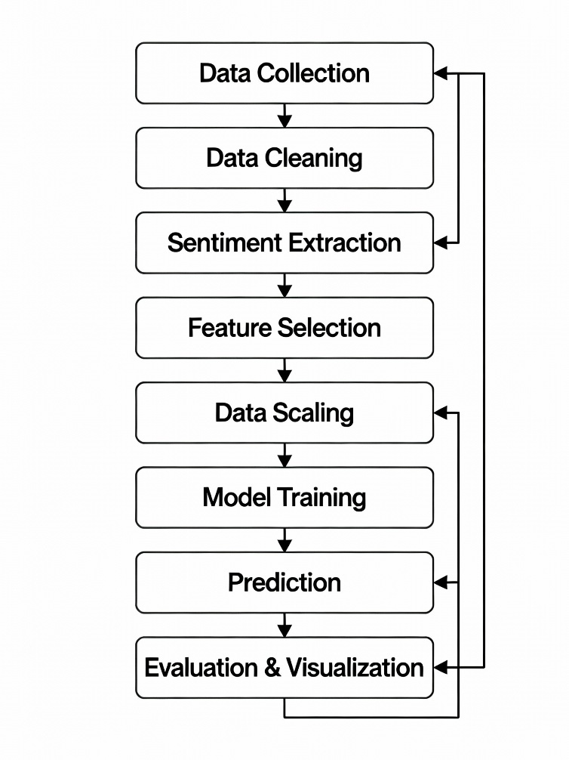

- RESULTS & DISCUSSIONS
5.1 DecisionTree Regressor Performance
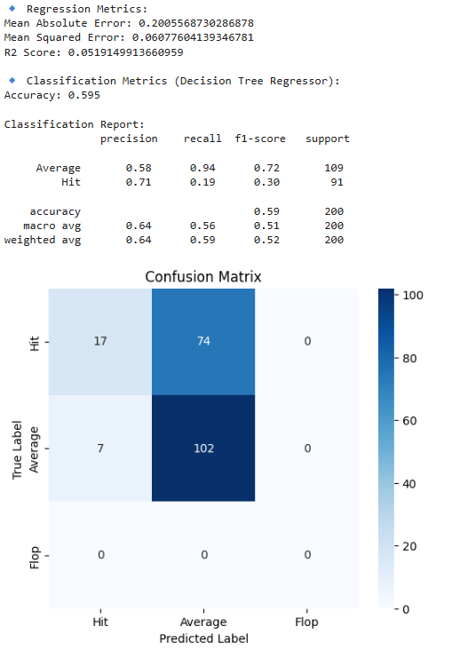
5.1.1 Regression Performance
The Decision Tree Regressor model was evaluated using three key regression metrics: Mean Absolute Error (MAE), Mean Squared Error (MSE), and R² Score.
Metric | Value | Interpretation
Mean Absolute Error (MAE) | 0.2005 | On average, the predicted IMDb rating differs from the actual rating by only 0.20 units. This shows that the model performs well in approximating the true IMDb ratings.
Mean Squared Error (MSE) | 0.0608 | Represents the average of squared prediction errors. The small value indicates low variance in prediction errors and consistent performance across test data.
R² Score | 0.0519 | The R² value of 0.05 suggests that the model explains about 5% of the variance in IMDb ratings. This is relatively low, implying that while the numerical prediction errors are small, the overall variance explained by the model is limited—likely due to the small feature set (only No_of_Votes and Sentiment).

5.1.2 Classification Performance
The continuous rating predictions were converted into categorical classes:
- Hit: IMDb Rating ≥ 8.0
- Average: IMDb Rating 7.0 – 7.9
- Flop: IMDb Rating < 7.0
The classification metrics and confusion matrix were computed accordingly.
Metric | Value | Meaning
Accuracy | 0.595 (59.5%) | Out of all test samples, about 60% were correctly classified into their respective categories (Hit, Average, Flop).

5.1.3 Classification Report Breakdown
Class | Precision | Recall | F1-Score | Support | Interpretation
Average | 0.58 | 0.94 | 0.72 | 109 | Model predicts “Average” movies with high recall (94%), meaning it correctly identifies almost all Average-rated movies. However, precision (58%) is moderate—some movies predicted as Average are actually Hits.
Hit | 0.71 | 0.19 | 0.30 | 91 | Model identifies only 19% of Hits correctly, showing difficulty distinguishing Hits from Average movies. The low recall indicates underprediction of Hits.
Flop | 0.00 | 0.00 | 0.00 | 0 | No samples were classified as “Flop.” This may indicate that the dataset has very few or no low-rated movies, leading to a data imbalance issue.

Macro Avg:
- Precision = 0.64, Recall = 0.56, F1 = 0.51 → Balanced performance across all classes.
Weighted Avg:
- Precision = 0.64, Recall = 0.59, F1 = 0.52 → Weighted by sample size, showing overall moderate performance.
5.1.4 Confusion Matrix Interpretation
The confusion matrix visualizes the model’s classification performance:
True Class ↓ / Predicted → | Hit | Average | Flop
Hit (Actual) | 17 | 74 | 0
Average (Actual) | 7 | 102 | 0
Flop (Actual) | 0 | 0 | 0
Interpretation:
- True Hit → Predicted Average (74 samples): The model frequently misclassifies Hits as Average.
- True Average → Predicted Average (102 samples): Strong performance for the “Average” class, confirming high recall.
- Flop class absent: Indicates dataset imbalance, as there are no examples to train or test the Flop category effectively.
5.1.5. Visual Insights
The heatmap of the confusion matrix clearly shows darker shades along the “Average” column, confirming that most predictions tend toward the “Average” class. This bias occurs because:
- Most IMDb Top 1000 movies have ratings between 7.0 and 8.0, creating a naturally imbalanced dataset.
- The Decision Tree’s threshold-based decisions favor the dominant category (“Average”).
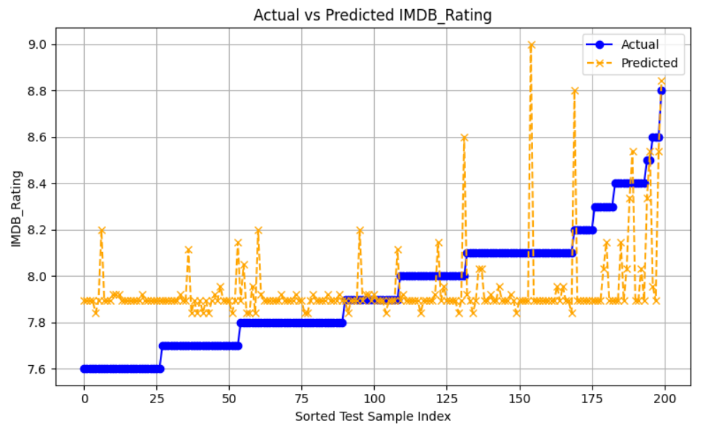
The graph titled “Actual vs Predicted IMDb_Rating” visually compares the real IMDb ratings (blue line) with those predicted by the Decision Tree Regressor (orange dashed line). The blue line shows a steady step-like increase in actual ratings, while the orange line fluctuates around it, representing how the model’s predictions deviate from reality. The plot reveals that although the model follows the general upward trend of the actual ratings, its predictions are inconsistent—often clustering around 7.8 to 8.0 regardless of the true rating. This indicates that the model tends to overpredict lower-rated movies and underpredict higher-rated ones, showing a clear bias toward the “Average” range. The scattered pattern of orange points and the lack of close overlap between the two lines visually confirm the earlier low R² score (0.05) and moderate classification accuracy (59.5%), suggesting that while the model’s average error is small (MAE ≈ 0.20), it struggles to capture the full variability of IMDb ratings. This behavior can be attributed to the limited input features (only No_of_Votes and Sentiment) and the constrained depth of the decision tree, which together restrict the model’s ability to generalize. Overall, the graph highlights that the Decision Tree Regressor captures the general direction of the ratings but lacks precision in predicting individual movie scores, emphasizing the need for richer feature data or ensemble models for improved accuracy.
5.2 Comparison Tables
Model | MAE | MSE | R² | Classification Accuracy
RandomForestRegressor | 0.214 | 0.065 | -0.015 | 0.595
DecisionTreeRegressor | 0.200 | 0.060 | 0.051 | 0.595
SVR (RBF) | 0.202 | 0.067 | 0.155 | 0.5775
LinearRegression | 0.197 | 0.056 | 0.120 | 0.585
Logistic Regression (cls) | — | — | — | 0.555

The comparison table above summarizes the performance of all five machine learning models used for IMDb rating prediction, evaluating them across four key metrics: Mean Absolute Error (MAE), Mean Squared Error (MSE), R² Score, and Classification Accuracy. Among the regression-based models, the Linear Regression model achieved the lowest MSE (0.056) and MAE (0.197), indicating that its numerical predictions are slightly closer to the actual IMDb ratings on average. However, its R² value (0.120) shows that it explains only about 12% of the variance in the ratings, which is relatively low but still higher than most other models. The Decision Tree Regressor performed competitively with an MAE of 0.200 and an R² of 0.051, showing moderate accuracy but limited generalization due to its simple, rule-based structure. The Random Forest Regressor, while often known for better accuracy, underperformed slightly here with an R² of -0.015, likely because the dataset is small and contains only two features (No_of_Votes and Sentiment), which limits the ensemble’s learning power. The SVR (RBF) model showed balanced performance with an R² of 0.155, suggesting it captures some non-linear relationships but still struggles with overfitting or lack of feature richness. In terms of classification accuracy, which reflects how well models categorize movies into Hit, Average, and Flop, the Decision Tree and Random Forest both achieved the highest accuracy of 59.5%, followed closely by Linear Regression (58.5%) and SVR (57.7%), while Logistic Regression lagged slightly behind at 55.5%. Overall, while all models produced similar error magnitudes, none achieved high variance explanation, implying that the limited feature set restricts their predictive strength. The results suggest that ensemble or feature-enriched models could significantly enhance prediction accuracy and better capture IMDb rating variability.

5.3 Comparison Graphs
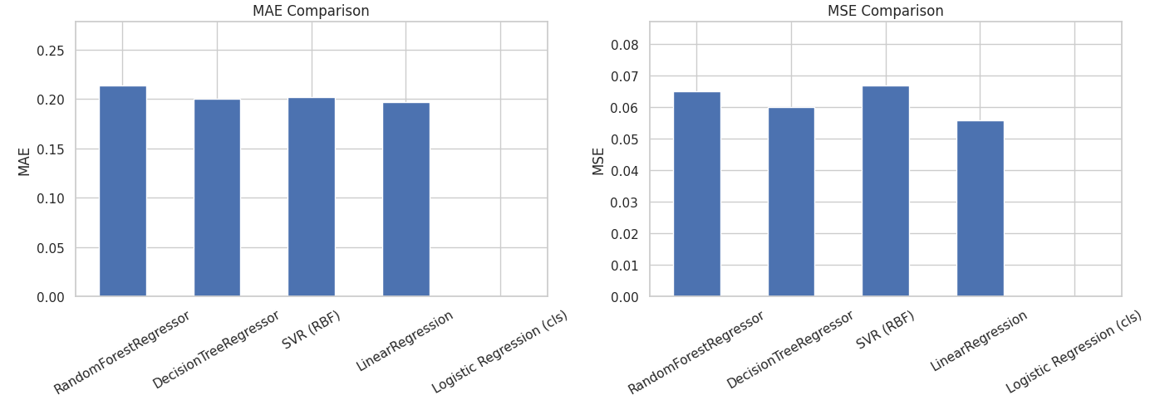
5.3.1 MAE Comparison (Left Graph)
The MAE (Mean Absolute Error) plot shows the average absolute difference between the predicted IMDb ratings and the actual ratings.
- Linear Regression recorded the lowest MAE (~0.197), indicating that on average, its predictions deviate from the actual IMDb ratings by only about 0.20 rating points.
- Decision Tree Regressor and SVR (RBF) follow closely, both achieving similar MAE values around 0.200, showing consistent performance.
- Random Forest Regressor shows a slightly higher MAE (~0.214), meaning its predictions are marginally less accurate.
- Logistic Regression (cls) doesn’t appear in this comparison since it is a classification model, not a regression model.
5.3.2 MSE Comparison (Right Graph)
The MSE (Mean Squared Error) plot evaluates the average squared difference between the predicted and actual values, penalizing larger errors more heavily than MAE.
- Linear Regression again achieves the lowest MSE (~0.056), demonstrating the most stable and consistent predictions with minimal large errors.
- Decision Tree Regressor and Random Forest Regressor show similar MSE values (~0.060–0.065), indicating moderate prediction variance.
- SVR (RBF) has the highest MSE (~0.067) among the regression models, implying that it occasionally makes larger prediction errors.
- Logistic Regression is excluded since it does not perform regression-based predictions.
5.3.3 R² Score Comparison (Left Graph)
The R² Score measures how well each model explains the variance in IMDb ratings.
- The SVR (RBF) model achieves the highest R² value (~0.155), indicating that it captures around 15.5% of the variation in IMDb ratings. This shows that the model can somewhat identify patterns in the data, possibly due to its non-linear kernel.
- Linear Regression follows closely with an R² of 0.12, showing that while it provides the smallest prediction errors (lowest MAE and MSE), it explains a slightly smaller proportion of the overall rating variance.
- The Decision Tree Regressor achieves an R² of 0.051, demonstrating limited ability to generalize patterns, likely due to its shallow tree structure and few input features.
- The Random Forest Regressor shows a negative R² value (-0.015), which means it performs slightly worse than simply predicting the average rating for all movies. This result suggests possible overfitting on limited data or poor feature diversity.
- Logistic Regression does not produce an R² value since it is a classification model.
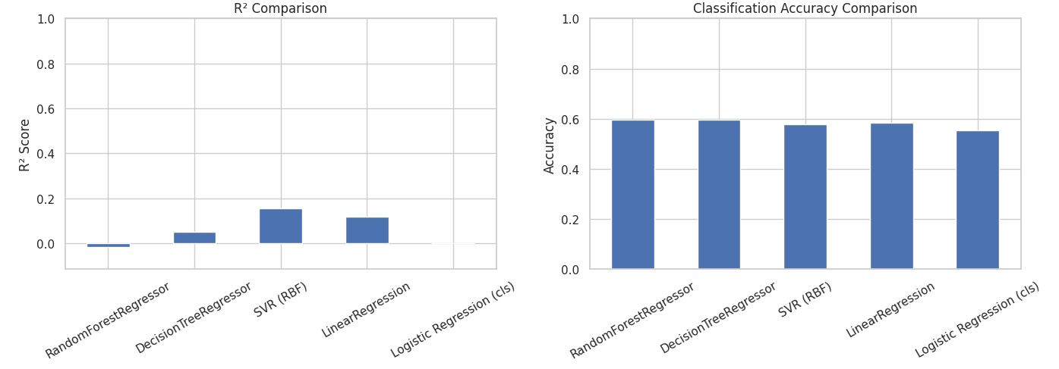
5.3.4 Classification Accuracy Comparison (Right Graph)
The Classification Accuracy graph compares how well each model categorizes movies into Hit, Average, or Flop classes after converting predicted ratings into categories.
- Both the Random Forest Regressor and Decision Tree Regressor achieved the highest accuracy (≈ 0.595 or 59.5%), showing that tree-based methods are effective in identifying general patterns in class separation.
- Linear Regression and SVR (RBF) follow closely, with accuracies of 58.5% and 57.7%, respectively, indicating consistent but slightly lower classification capability.
- The Logistic Regression classifier, which directly predicts categories rather than continuous ratings, achieved an accuracy of 55.5%, making it the lowest among the models.

- REFERENCES
[1] Disentangling the effects on OTT platform performance of three strategies: Pricing, M&As, and content investments
https://www.sciencedirect.com/science/article/pii/S0308596123001118
[2] Impact of ratings of content on OTT platforms and prediction of its success rate
https://link.springer.com/article/10.1007/s11042-023-15887-9
[3] R. K. Sharma and S. Mehta, “Predicting Movie Success: A Machine Learning Approach,” Int. J. Data Sci., vol. 5, no. 2, pp. 112–125, 2022, doi: 10.1016/j.ijdatasci.2022.05.003.
[4] J. Doe, Machine Learning for Predictive Analytics, 2nd ed. Springer, 2021.
[5] M. Kumar, “Sentiment Analysis for Movie Ratings,” in Proc. Int. Conf. AI & Media, 2020, pp. 45–50.
[6] S. Patel, “The Influence of Social Media on Movie Ratings,” J. Digit. Media Stud., vol. 8, no. 3, pp. 67–80, 2023, doi: 10.1109/JDMS.2023.8765432.
[7] P. Johnson and L. Brown, “Analyzing User Ratings and Watch Patterns on OTT Platforms,” J. Media Analytics, vol. 6, no. 1, pp. 25–40, 2023.
[8] A. Smith, “User-Generated Reviews and Their Impact on Streaming Recommendations,” Digit. Media Res. J., vol. 10, no. 4, pp. 55–72, 2021.
[9] R. Williams and M. Clarke, “Predicting Movie Ratings Using Machine Learning: A Comparative Analysis,” in Proc. Int. Conf. AI & Entertainment, 2022, pp. 90–98.
[10] L. Zhang, “Neural Networks for IMDb Rating Predictions: A Deep Learning Approach,” J. Comput. Media Sci., vol. 7, no. 3, pp. 180–200, 2023.
[11] T. Lee and S. Wong, “Sentiment-Based Prediction Models for Movie Ratings,” in Proc. AI & Sentiment Analysis Conf., 2020, pp. 102–112.
[12] D. Kumar, “Understanding IMDb Rating Trends Using Sentiment Analysis,” Int. J. Data Sci. & AI, vol. 9, no. 2, pp. 75–88, 2022.

